Assignment-5
Aggregate Functions , Grouping and Nested Queries
1. Replace all occurrences of the letter ‘A’ with ‘E’ in the word MALAYALAM.
A:
2. Display the employee name and commission, replacing NULL commission values with 0.
A: SELECT ename,comm, COALESCE(comm,0) as sal FROM emp ;
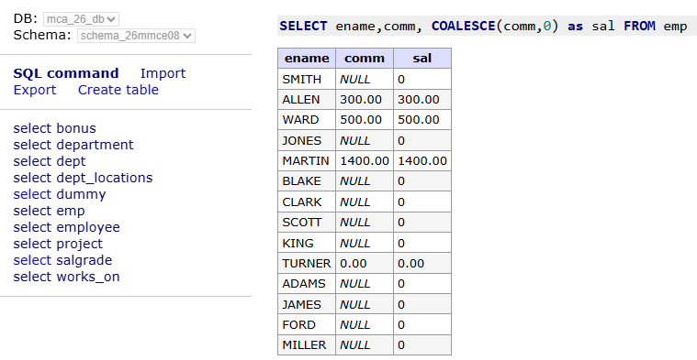
3. Find the total number of employees working as clerks.
A: SELECT COUNT(*) FROM emp WHERE job = 'CLERK';
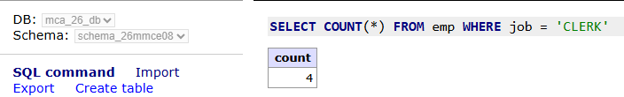
4. Display the department number and the total number of employees working in each department.
A: SELECT deptno, COUNT(*) as tota_emp FROM emp GROUP BY deptno;
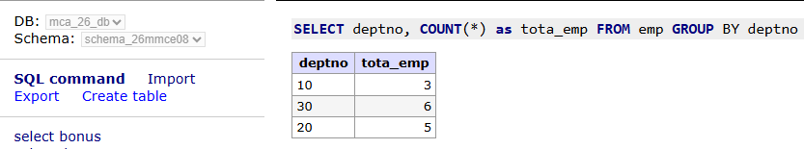

5. Find the number of clerks who joined the company after 1 January 1981.
6. Display the employee name and total salary, including commission. Replace NULL commission with 0.
7. Find the annual compensation of all managers, calculated as (12 times (SAL + COALESCE(COMM,0))).
8. Find the average salary of all salesmen.
9. Display the name and salary of the highest-paid employee in the company.
10. Display the names, department numbers, and salaries of the highest-paid employees in each department.
11. Display the employee name that comes first in alphabetical order.
12. Find the minimum salary for each job category.
13. Display the maximum salary for each combination of department number and job.
14. Display the job categories and department numbers where the maximum salary is greater than 1500.
15. Find the minimum and maximum salaries of managers in each department.
16. Display the names, jobs, salaries, and department numbers of employees working in the same department as SMITH.
17. Display the employee name, job, annual salary, and department number of employees earning more than JONES.
18. Display the employees who joined the company after MILLER.
19. Find all employees who earn more than every employee working in department 30.
20. Find the second-highest distinct salary in the company.

